UNITED STATES

SECURITIES AND EXCHANGE COMMISSION

Washington, D.C. 20549

FORM 6-K

REPORT OF FOREIGN PRIVATE ISSUER PURSUANT TO RULE 13a-16 OR 15d-16

UNDER THE SECURITIES EXCHANGE ACT OF 1934

For the month of April 2024

Commission File Number: 001-39458

Medicenna Therapeutics Corp.

(Translation of registrant’s name into English)

2 Bloor St. W. 7th Floor
Toronto, Ontario M4W 3E2

Canada

(Address of principal executive office)

Indicate by check mark whether the registrant files or will file annual reports under cover of Form 20-F or Form 40-F.

☒ Form 20-F ☐ Form 40-F

SIGNATURES

Pursuant to the requirements of the Securities Exchange Act of 1934, the registrant has duly caused this report to be signed on its behalf by the undersigned, thereunto duly authorized.

MEDICENNA THERAPEUTICS CORP.

(Registrant)

Date: April 26, 2024 By: /s/ Fahar Merchant

Name: Fahar Merchant, PhD

Title: Chief Executive Officer

 |  |  |  | Form 6-K Exhibit Index
Exhibit
Number |  |  |  | Document Description
99.1 |  |  |  | Press Release of the Registrant dated April 26, 2024


Exhibit 99.1

Medicenna Therapeutics Announces CA$20 Million Investment from RA Capital Management

Not for distribution to United States news wire services or for dissemination in the United States

TORONTO and HOUSTON, April 26, 2024 – Medicenna Therapeutics Corp. (“Medicenna” or the “Company”) (TSX: MDNA)(MDNAF: OTCQB), a clinical-stage immunotherapy company focused on the development of engineered cytokines, today announced a CA$20 million investment by RA Capital Management, a multi-stage investment manager based in Boston, MA, by way of a non-brokered private placement (the “Offering”). Medicenna intends to use the net proceeds from the Offering for further development of its MDNA11 program, advancement of its preclinical programs and general corporate purposes.


Pursuant to the terms of a subscription agreement entered into as of the date hereof between the Company and RA Capital Healthcare Fund, L.P. (“RAHF”), a fund affiliated with RA Capital Management, RAHF will subscribe for 5,141,388 common shares in the capital of the Company (the “Shares”) at a price of CA$1.95 per share and, in lieu of common shares, pre-funded warrants to purchase 5,141,388 common shares (the “Pre-Funded Warrants”) at a purchase price of $1.94 per pre-funded warrant for total net proceeds to the Company of approximately CA$20 million.

The Offering is expected to close on or about April 30, 2024 and is subject to the approval of the TSX.

“We are excited to announce the financial backing by RA Capital Management as a result of promising single-agent clinical activity of MDNA11, our differentiated IL-2 superkine,” said Dr. Fahar Merchant, President and CEO of Medicenna. “With this funding, we have strengthened our balance sheet at a time of strong momentum, demonstrated enthusiasm for our platform by attracting a prestigious investor and extended our cash runway well into 2026 enabling us to exploit the deep clinical potential of MDNA11 and our pipeline of early-stage superkines.”

The Shares and Pre-Funded Warrants have not been and will not be registered under the United States Securities Act of 1933, as amended (the “U.S. Securities Act”), or any U.S. state securities laws and may not be offered or sold within the “United States” or to “U.S. Persons” (as such terms are defined in Regulation S under the U.S. Securities Act) unless registered under the U.S. Securities Act and applicable state securities laws or pursuant to an applicable exemption from such registration is available.

This news release shall not constitute an offer to sell or a solicitation of an offer to buy these securities, nor shall there be any sale of these securities in any state or other jurisdiction in which such offer, solicitation or sale would be unlawful prior to the registration or qualification under the securities laws of any such state or other jurisdiction.

About Medicenna

Medicenna is a clinical-stage immunotherapy company focused on developing novel, highly selective versions of IL-2, IL-4 and IL-13 Superkines and first-in-class empowered superkines. Medicenna’s long-acting IL-2 Superkine, MDNA11, is a next-generation IL-2 with superior affinity toward CD122 (IL-2 receptor beta) and no CD25 (IL-2 receptor alpha) binding, thereby preferentially stimulating cancer-killing effector T cells and NK cells. Medicenna’s IL-4 Empowered Superkine, bizaxofusp (formerly MDNA55), has been studied in 5 clinical trials enrolling over 130 patients, including a Phase 2b trial for recurrent GBM, the most common and uniformly fatal form of brain cancer. Bizaxofusp has obtained FastTrack and Orphan Drug status from the FDA and FDA/EMA, respectively. Medicenna’s early-stage BiSKITs™ (Bifunctional SuperKine ImmunoTherapies) and the T-MASK™ (Targeted Metalloprotease Activated SuperKine) programs are designed to enhance the ability of Superkines to treat immunologically “cold” tumors.

For more information, please visit www.medicenna.com, and follow us on Twitter and LinkedIn.

1

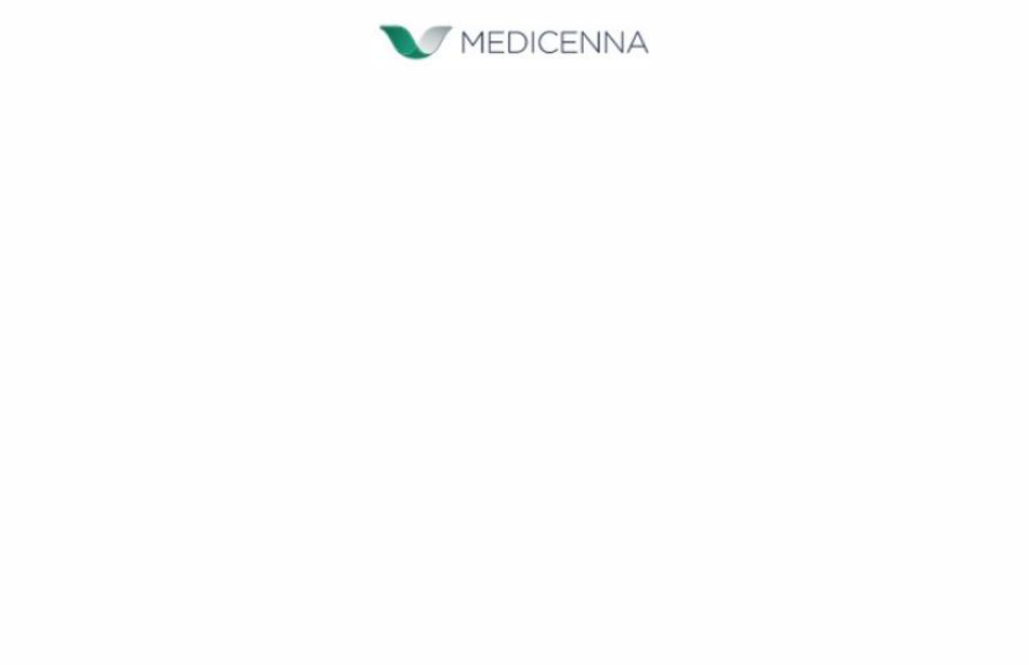
Forward-Looking Statements

This news release contains forward-looking statements within the meaning of applicable securities laws. All statements in this news release, other than statements of historical facts, that address events or developments that the Company expects to occur, are forward-looking statements, including, but are not limited to, statements relating to the Offering and the terms thereof, the anticipated closing date, the proposed use of proceeds from the Offering, and the receipt of the approval of the TSX. Forward-looking statements also include express or implied statements regarding the future operations of the Company, estimates, plans, strategic ambitions, partnership activities and opportunities, objectives, expectations, opinions, forecasts, projections, guidance, outlook or other statements that are not historical facts, such as statements on the Company’s cash runway, preclinical and clinical development activities, clinical trial designs, clinical potential, expectations and beliefs around safety profiles and upcoming milestones and data reporting, including with respect to MDNA11, the ABILITY study and its expansion, bizaxofusp (MDNA55), MDNA113 and MDNA223. Drug development and commercialization involve a high degree of risk, and only a small number of research and development programs result in commercialization of a product. Results in early-stage clinical studies may not be indicative of full results or results from later stage or larger scale clinical studies and do not ensure regulatory approval. You should not place undue reliance on these statements or the scientific data presented. Forward-looking statements are often identified by terms such as “will”, “may”, “should”, “anticipate”, “expect”, “believe”, “seek”, “potentially” and similar expressions. Forward-looking statements are based on a number of assumptions believed by the Company to be reasonable at the date of this news release. Although the Company believes that the expectations reflected in such forward-looking statements are reasonable, there can be no assurance that such statements will prove to be accurate. These statements are subject to certain risks and uncertainties and may be based on assumptions that could cause actual results and future events to differ materially from those anticipated or implied in such statements. Important factors that could cause actual results to differ materially from the Company’s expectations include the risks detailed in the latest Annual Report on Form 20-F of the Company and in other filings made by the Company with the applicable securities regulators from time to time in Canada.

The reader is cautioned that assumptions used in the preparation of any forward-looking information may prove to be incorrect. Events or circumstances may cause actual results to differ materially from those predicted, as a result of numerous known and unknown risks, uncertainties, and other factors, many of which are beyond the control of the Company. The reader is cautioned not to place undue reliance on any forward-looking information. Such information, although considered reasonable by management, may prove to be incorrect and actual results may differ materially from those anticipated or implied in forward-looking statements. Forward-looking statements contained in this news release are expressly qualified by this cautionary statement. The forward-looking statements contained in this news release are made as of the date hereof and except as required by law, we do not intend and do not assume any obligation to update or revise publicly any of the included forward-looking statements.

2


This news release contains hyperlinks to information that is not deemed to be incorporated by reference in this news release.

Investor and Media Contact:

Christina Cameron

Investor Relations, Medicenna Therapeutics

ir@medicenna.com

(647) 953-0673

3

